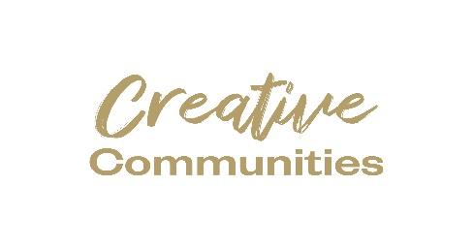
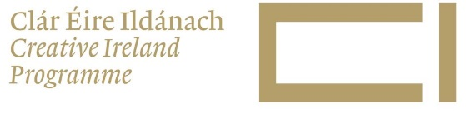
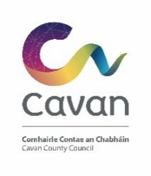

Creative Cavan 2024 – Guidance Notes
Background
Creative Cavan invite individuals and organisations to submit proposals for Cruinniú na nÓg 2024 as part of the Creative Cavan Programme
Cruinniú na nÓg empowers children and young people to develop their creative expression by providing opportunities for them to participate in free creative activities in their local area. It’s Ireland’s national day for ‘doing’, ‘making’ and ‘creating’! This year Cruinniú na nÓg will take place on Saturday 15 June across the country.
Proposals can include ANY and ALL creative activities, performances, readings, workshops, interactive installations, etc. that can run in the lead up to Cruinniú with a main event on 15 June 2024 OR a one-off event happening on 15 June 2024.
We are looking for ALL types of creatives to engage with children and young people aged 0-18 in the form of activities, performances, developmental workshops, or projects.

Activities should be child centered, foster creativity and engage a diverse audience, through a range of creative forms. Priority will be given (where possible) to harder to reach children and young people (i.e. children with disabilities, seldom heard children, direct provision) and we are seeking a wide geographical spread throughout the county.

To be eligible for funding the project/event:
- Must take place in County Cavan and include an element of delivery on 15 June 2024.
- Applicants must be 18 years or older.
- Be organised by an individual/community/voluntary group based in Cavan.
- Encourage or benefit participation in the Creative Ireland programme and enhance the awareness of creativity or culture in the County.
- Recipients of grant assistance for projects involving children or young people must show evidence that a current child protection policy and up to date Garda Vetting are in place.
- Cavan County Council and Creative Ireland logos should appear on all printed material, and be acknowledged on all video/film, event websites, and social media.
- It is the responsibility of the grant recipient to follow public health recommendations and guidelines in relation to COVID 19
- Details of all projects will be advertised on the Creative Cavan and Creative Ireland website.
- Be designed on a realistic financial basis and provide good value for money.

Application information
- Application Deadline CLOSING DATE: 5 pm 7 march 2024 to creativecavan@cavancoco.ie or online using the form provided. LATE APPLICATIONS WILL NOT BE CONSIDERED.
- Applicants should NOT contact the Creative Ireland Office after this date. You will be notified by mid-March by email, as to whether you have been successful or not. (Please note your project can not start until you have been notified as to whether you are successful, and this should be considered when proposing your ideas to us. Cavan County Council will not retrospectively fund and take no responsibility for proposed projects that have not been awarded funding by due process.
- It is the responsibility of the applicant to ensure that all permissions, approvals, licences or GDPR consents needed for your project are secured.
- Stock imagery is fine to use provided that the image is marked as such.
- Images including recognisable participants must be accompanied by the relevant GDPR form supplied as part of the funding agreement.

Items that are excluded from the fund include:
- Capital requests for building improvements to workspaces and venues.
- Assets or equipment e.g.: vouchers, memoirs for participants, art works, projectors, laptops, tablets etc.
- Fuel Costs.
- Spends on alcoholic beverages, food, fines, legal costs, penalty payments, and prizes.
- Wages and salaries relating to administrative costs.
- Generally, the cost of items for resale is ineligible.
- Items of expenditure incurred prior to the approval of grant funding are not eligible for recoupment.
- Activities dedicated solely to sport and fitness.
- Applicants requesting assistance in respect of commercial activities.
- Charitable events.
- Applications for activities that are completed or have already commenced.
- Applications from employees of Cavan County Council. These individuals may not apply as lead applicants, however in certain circumstances can be involved as creative collaborators / advisors / participants in proposals submitted by a third party.
- Activities better suited to others awards and/or schemes offered by the county council.
- Activities that could be better supported by other public agency supports for example Arts Council, Culture Ireland, Design & Crafts Council Ireland, Music Generation.

Assessment Process:
- All applications will be assessed by an independent panel.
- Funding will be allocated based on the recommendations of this panel.
- All applicants will be advised of the decision by email.
- Successful applicants will receive a letter of offer and a funding agreement document that details terms and conditions. This document must be signed and returned by the date specified on the letter of offer. Failure to do so may result in funding being withdrawn and reallocated to another project.
- Due to resource constraints, it may not be possible to allocate funding to all projects, and eligibility and compliance with these criteria do not guarantee a letter of offer.

Policies and Guidelines

CLOSING DATE: 5 pm 7 march 2024

If I am successful how do I draw down the Fund

Payment will be made when the project is completed and a final report is submitted (as per the criteria in the Funding Agreement) to the Creative Cavan Office.

Note: Payment will be made to the community group named on the application form, and not to individuals- the community group must have its own designated bank account.
Payment will be by Electronic Funds Transfer only. A Supplier Set Up Form and Bank details must be submitted to facilitate the transfer.

Acknowledgment- Successful applicants must ensure that their project is promoted as part of the Creative Ireland initiative. Appropriate guidelines to support this will be included in the Creative Cavan Funding Agreement.

Freedom of Information:

Applicants completing this Form should note that information provided to the Cavan Creative Ireland programme of Cavan County Council may be disclosed in response to a request made under The Freedom of Information Act (1997 and 2003). Every effort will be made to protect Client confidentiality.

